Management Information Systems, 16E

Laudon & Laudon

Lecture Files, Barbara J. Ellestad

Chapter 11 Managing Knowledge and Artificial Intelligence

“A business is, in essence, a vast collection of knowledge and information. It's what's behind the creation of benchmark products and services, and it exists as a web of insights and ideas shared by staff. It's in your documentation—your manuals, guidelines, lists, databases, memos, and files. And it's also in the minds of your team members, as the expertise you need to capture to enhance your business. Knowledge is power, and when properly harnessed, it fuels a successful company. Technology has had a tremendous impact on knowledge management (KM), inspiring the development of robust software platforms to leverage KM strategies. Knowledge management software continues to evolve in response to new demands and challenges.” (15 Hot Knowledge Management Trends for 2019, https://axerosolutions.com, July 21, 2018)

As we’ve mentioned in other chapters, information, therefore knowledge, is becoming an important corporate resource that must be captured, protected, preserved, and grown. How you do that is the focus of this chapter.

11.1 What is the role of knowledge management systems in business?

Creating and using knowledge is not limited to information-based companies; it is necessary for all organizations, regardless of industry sector. It’s not enough to make good products. Companies must make products that are better, less expensive to produce, and more desirable than those of competitors. Using corporate and individual knowledge assets wisely will help companies do that. They must harness as much knowledge as they can and make it easy to share with others.

Important Dimensions of Knowledge

We discussed the difference between data and information in previous chapters. The next step up from information literacy is knowledge. An organization must transform the information it gathers and put it into meaningful concepts that give it insight into ways of improving the environment for its employees, suppliers, and customers. Wisdom then is using information to solve problems and knowing when, where, and how to apply knowledge.

You may have associated with the long-time employee that seems to know how to fix the intricate piece of machinery in his sleep. He’s been doing it for years, he would tell you. All of the knowledge he retains in his mind is tacit knowledge. On the other hand, you may have dealt with an employee who seems to grab the operating manual every time he turns around. The manual is an example of explicit knowledge—that which is documented.

Table 11.1 below shows that every organization has four dimensions of knowledge:
- Knowledge is a firm asset.
- Knowledge has different forms.
- Knowledge has a location.
- Knowledge is situational.

How it handles them is what can make the organization a successful one that seems to outrun the competition, or one that seems to muddle through the best it can. Examine your organization and determine how well it values its knowledge.

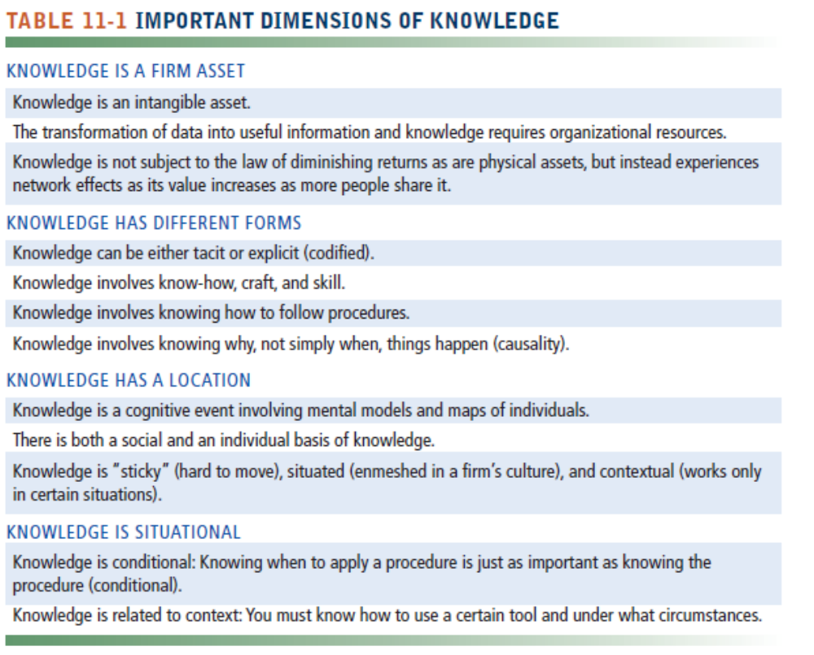

Organizational Learning and Knowledge Management

In the last few years, companies have downsized and flattened their organizations. Many employees who were laid off had been with these companies for years. When they walked out the door, they took experience, education, contacts, and information with them. Companies are finding out how important human resources are to their success and are establishing organizational learning mechanisms to capture and use this corporate knowledge.

That is, organizations gain experience by:
- Collecting data
- Measuring planned activities
- Experimenting through trial and error
- Gathering feedback from customers and the environment

Successful organizations then incorporate what they’ve learned into new business processes and new management decision-making skills.

The Knowledge Management Value Chain

To understand the concept of knowledge management, think of knowledge as a resource, just like buildings, production equipment, product designs, and money. All these resources need to be systematically and actively managed.

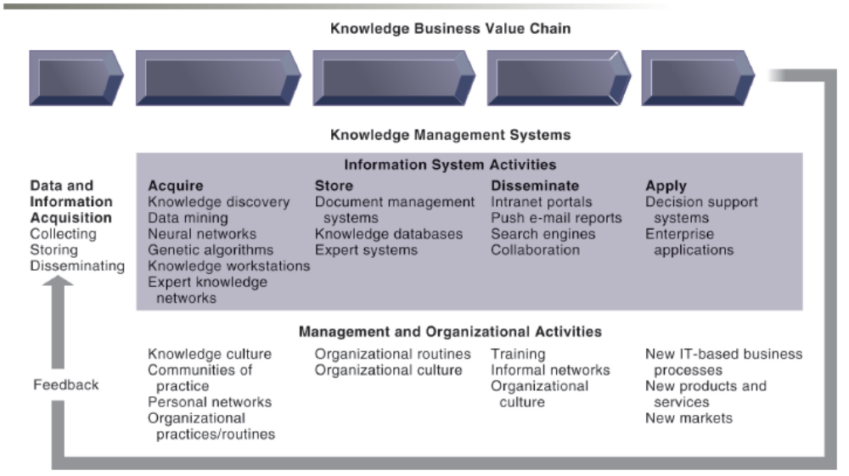

Figure 11.1: The Knowledge Management Value Chain

Figure 11.1 shows you the activities that go into successfully managing knowledge from acquiring it to applying it throughout the firm. It’s not just technology related to the activities that’s important to recognize. In fact, as the text points out, technology applications of managing knowledge account for only about 20 percent. The other 80 percent deals with organizing and managing the knowledge assets.

Knowledge Acquisition

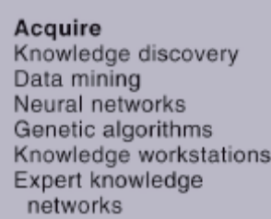

Figure 11.1a: Acquiring Knowledge

Knowledge comes from a variety of sources. Early attempts of gathering knowledge were a hodgepodge of documents, reports, and employee input. Now companies are using more sophisticated technologies to gather information and knowledge from e-mails, transaction-processing systems, and outside sources such as news reports and government statistical data. It’s important to remember that a great deal of knowledge should come from external sources because no organization exists in a vacuum.

Knowledge Storage

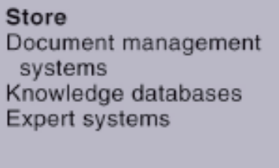

Figure 11.1b: Storing Knowledge

Remember, knowledge management is a continual process, not an event. As you gather knowledge you must store it efficiently and effectively. Document management systems are an easy way to digitize, index, and tag documents so that employees can retrieve them without much difficulty. Probably the most important element of any knowledge system is the people that feed the machine. One of the biggest reasons knowledge systems have failed in the past is because the employees and management either didn’t place enough importance on the system or felt threatened by it. All the people in the digital firm need to realize how important a resource knowledge is and help take care of the system.

Knowledge Dissemination

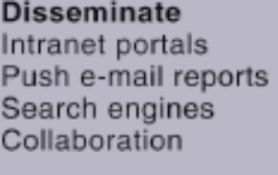

Figure 11.1c: Disseminating Knowledge

Once you’ve built the system, acquired and stored the knowledge, you need to make it easy and efficient for employees to access the knowledge. Portals, wikis, social networks, IM, and e-mail are just some of the tools you can use to disseminate information easily and cheaply. Everyone complains nowadays of having too much information. The organization needs to make knowledge dissemination unobtrusive and easy to master or the employees and managers will ignore it or underutilize it.

Knowledge Application



Figure 11.1d: Applying Knowledge

You can have all the information and knowledge you need to master any task, but if you don’t build knowledge application into every functional area and every system used throughout the organization you are doing a disservice to both the knowledge and the company. As old systems are revamped and revised or new ones built, pay attention to how you can draw knowledge into them. The digital firm also needs to explore how it can use the knowledge system to build new processes for its employees and suppliers, or new products for its customers. Once it masters that, it can outrun the competition and build a stronger organization.

Building Organizational and Management Capital: Collaboration, Communities of Practice, and Office Environments

As knowledge becomes a central productive and strategic asset, the success of the organization increasingly depends on its ability to gather, produce, maintain, and disseminate knowledge. One way companies are responding to the challenge is by appointing a chief knowledge officer (CKO). The CKO’s responsibilities involve designing new programs, systems, and methods for capturing and managing knowledge. In some cases, the hardest part of the CKO’s job may be convincing the organization that it needs to capture, organize, and use its corporate knowledge to remain competitive as the article below points out.

“At the highest level, Chief Knowledge Officer job, or CKO job, includes managing the processes, practices and technical specifications for the capture, retention and use/reuse of an organization’s knowledge.
Many organizations infuse knowledge management into content creation and collaboration, distributing Chief Knowledge Officer job through content leaders, marketing, and line-of-business professionals. Without a knowledge focal point, however, organizations can lose their connection, not with specific knowledge, but with the idea of knowledge as a strategic asset.
The CKO brings strategic focus and ownership. CKOs also help identify which classes of knowledge deliver value and therefore require attention, curation and nurturing. In this process of knowledge cultivation, CKOs discover knowledge that can apply to customer and market messaging. Knowledge plays a role not just as an internal operations advantage, but as a source of credibility and market leadership.
This raises another aspect of the CKO’s work, that of protector of knowledge. The CKO, along with the legal team, should act as the primary overseer of intellectual property policy. He or she should influence what knowledge an organization considers proprietary, as well as knowledge, deemed a competitive advantage.
Increasingly, the Chief Knowledge Officer job exists primarily in nearly pure knowledge businesses, such as research, management consulting, government agencies, and associations. The combination of knowledge cultivation and control, however, remains important, and many organizations would benefit from the leadership of a CKO.” (What is the Chief Knowledge Officer Job?, www.seriousinsights.net, Rasmus, Daniel W., May 11, 2018)

No one person has all the knowledge a digital firm needs. For that you must rely on many different people from many different locations. Communities of practice (COP) are built on the idea of combining ideas and knowledge from various sources and making it available to people inside and outside the organization. Professional conferences, newsletters, journals, and online newsgroups are excellent sources of information that center on the communities of practice concept.

Four areas where COP can make a difference are:

- Reuse knowledge
- Facilitate gathering new information
- Reduce learning curves
- Act as a spawning ground for new knowledge

Types of Knowledge Management Systems

Let’s look at three major types of knowledge management systems as shown in Figure 11.2.

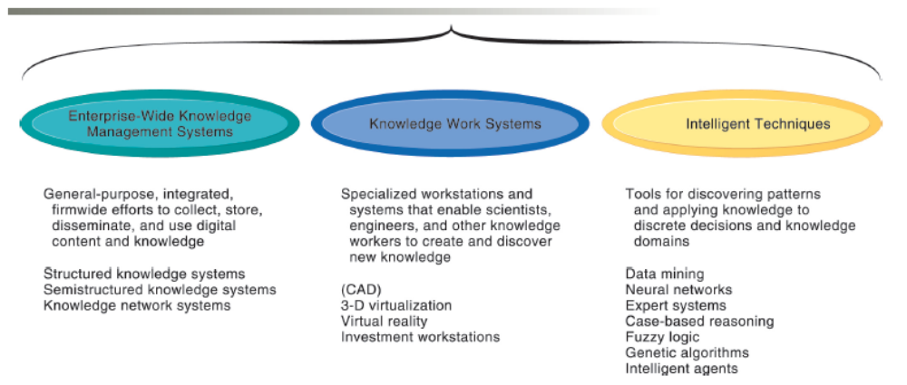
Figure 11.2: Major Types of Knowledge Management Systems

Enterprise-wide knowledge management systems are spread across the organization and offer a way to systematically complete the information system activities we just reviewed: acquiring, storing, disseminating, and applying knowledge.

Knowledge work systems use powerful workstations that can process the huge graphics files some professionals need or to perform the massive calculations other types of professionals require. We’re not talking clip art or simple addition or subtraction. We’re talking huge amounts of data that must be processed quickly and the necessary storage capacity for large files. The workstations must also have the necessary equipment and telecommunication connections that enable the knowledge workers to connect to external sources of information via extranets, intranets, or the Internet. These systems must have system and application software that is easy-to-use and manipulate, and intuitive to learn so the workers can “get right to it.”

Intelligent techniques, which we’ll look at more closely at the end of this chapter, include expert systems, neural networks, and genetic algorithms, to name a few.

Bottom Line: Knowledge is an important asset that must be managed throughout the enterprise. Knowledge must be acquired, stored, distributed, and applied effectively and efficiently. The chief knowledge officer is responsible for ensuring that the digital firm uses its knowledge assets wisely. Communities of practice help people reuse knowledge easily and cheaply.

11.2 What are artificial intelligence (AI) and machine learning? How do businesses use AI??

Artificial intelligence (AI) is not all about computers taking over the world and turning on their human inventors. Rather, many of the systems under the AI umbrella are useful tools for capturing, storing, and disseminating human knowledge and intelligence. Still other intelligent techniques help generate solutions to problems that can’t be solved by humans alone.

Evolution of AI

Major forces that have driven the AI movement and its improvements include:
- Big data databases
- E-commerce
- Internet of Things (IoT)
- Social media

Secondary drivers of the AI evolution include:
- Reduction in computer processing costs
- Growth in processor power

Major Types of AI

There are a multitude of AI systems, techniques, and technologies. Table 11.2 describes them.

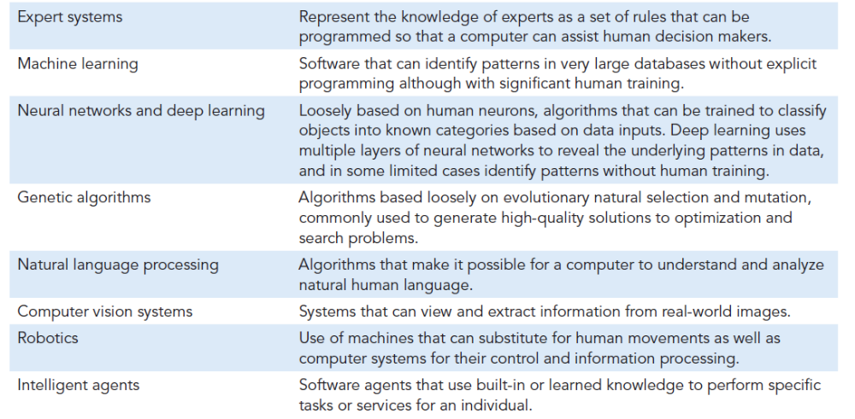
Table 11.2 Major Types of AI Techniques

Expert Systems

Expert systems are a common form of artificial intelligence. They are used to assist humans in the decision-making process, but they don’t replace humans. Many of the decisions we make are based on past experience, but we have the added benefit of reasoning and intuition. Expert systems ask questions, then give you advice and reasons why you should take a certain course of action based on hard data, not on hunches. Again, they don’t make the final decision.

Most of the problems an expert system helps resolve can, in fact, be solved by a human. But because the computer is faster or safer, businesses choose to use them instead of a person.

How Expert Systems Work

Expert systems rely on a knowledge base built by humans based on their experiences and knowledge. The base requires rules and knowledge frames in which it can process data. When you think about it, humans work the same way. You look out the window to see if it’s raining. If it is, then you grab your umbrella. If it’s not raining, then you don’t. There you have it, a rule base.

Yes, we used a very simplified example. Most expert systems require thousands of rules and frames in which to operate in a rule-based expert system. The knowledge must be specific. In the example above, you wouldn’t take any action if the only information you had was “It rains 350 days a year in the Amazon rain forest.” Neither would an expert system.

The programming environment of an expert system uses rules, frames, and an inference engine to accomplish its tasks. The inference engine uses forward chaining or backward chaining to move through the rules and the frames.

Machine Learning

If you’ve made a purchase on Amazon.com or a clothing web site such as JCPenney, you’ve probably seen a feature displaying suggestions about what other people purchased when they purchased your item. How does the web site know that? Because as people make purchases and view similar items, the computer running the web site captures all that data and feeds it into an algorithm. The machine running the web site “learns” about the preferences. As thousands and millions of people make purchases and view other items the machine learning capabilities of the knowledge management system used by Amazon.com and JCPenney’s are altered for future use.

Machine learning allows computer systems to recognize patterns in data and change their behavior based on their recognition of patterns, experience, or prior knowledge. The use of machine learning has greatly expanded over the past few years because of improvements in algorithm design, growth of databases including “Big Data,” and the increase in raw computing power available in today’s computer systems.

Supervised and Unsupervised Learning

There are two types of learning involved with computers and machines.

Supervised learning involves programmers and other technology workers to ‘teach’ computer programs in a hands-on way by giving it examples of right answers or right procedures. The humans guide the computer to learn certain facts or certain steps. At a point, the computer begins to learn on its own. The humans continually test the machine until they’re fairly confident the machine can produce correct results.

Unsupervised learning uses the same basic techniques except that the humans don’t give the machine any samples to learn from in the beginning.

Neural Networks

This type of knowledge system is as close to emulating the human ability to learn as we’ve been able to come. Let’s return to our umbrella example. How do you know to take an umbrella when it’s raining? You probably got wet a few times without one. Then you tried using one when it rained and discovered that you didn’t get wet. You learned that when it rains, an umbrella will keep you dry. That’s basically how neural networks work. This type of AI is based on patters and relationships using pattern detection programs.

You give a neural network data for which you already know the output, so that it has a base of correct information upon which it can build. When you give it new, different data, the computer will compare it with the previous data to determine what the correct outcome of the situation should be. If the data don’t fit, it figures out why. It adds that information to its current database of knowledge and then keeps taking in more data. It eventually learns the right outcome. The more data it takes in, and the more situations it gets right, the better it becomes at knowing the right answer to the next set of decisions.

“Deep Learning” Neural Networks

Deep learning networks are in their infancy. They are used almost exclusively for pattern detection on unlabeled data where the system is not told what to look for specifically but to simply discover patterns in the data. Figure 11.5 gives you an idea of how they work.

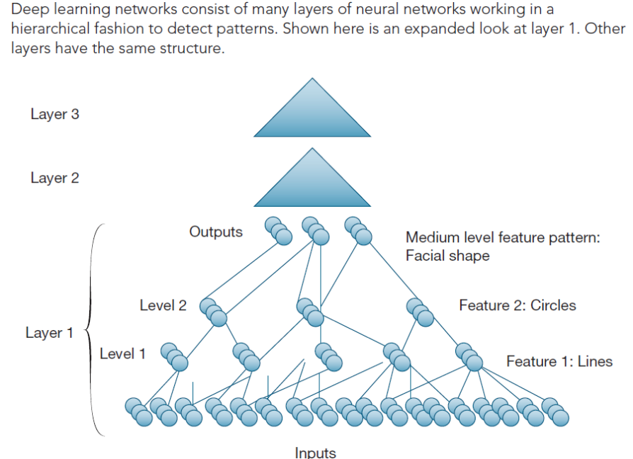
Figure 11.5 A Deep Learning Network

Limitations of Neural Networks and Machine Learning

Some of the limitations to all these forms of AI include:
- Require very large data sets to identify patterns
- Many patterns in large data sets are nonsensical
- Humans much choose which patterns make sense
- Large data sets may not last long
- Data sets large enough may not exist
- No sense of ethics

Genetic Algorithms

We’ve evolved as a human race through genetics. We are made up of many combinations of generations of humans. That’s how genetic algorithms work. Solutions to problems are examined by the system. The best solution is retained for future use, while the worst solutions are discarded. The solutions that are retained are used to help provide better solutions to future problems. They are combined and changed the next time they are used.

Businesses often need to solve problems that are dynamic, complex, and have many variables. Very few problems are clear-cut, black-and-white. Genetic algorithms are good systems for businesses to use because it’s almost like having millions of people coming at a problem from all directions.

Natural Language Processing, Computer Vision Systems, and Robotics

Let’s look at three more AI techniques that will affect your life in the future.

Natural Language Processing

Many people use their voice to enter commands to their computing devices rather than typing in text. This is more popular on smartphones than anywhere else. The device uses natural language processing to understand the user’s voice and carry out the task. Natural language differs from computer-generated language in that the natural way humans talk is what drives the computing device not a language that was developed strictly for the computer itself.

Computer Vision Systems

Computer visions systems use image processing, pattern recognition and image understanding to carry out processes and/or commands. These systems are especially useful for self-driving vehicles that use a large amount of data input from various sources to effectively work. It’s also how some smartphones can handle security by using images of your face to unlock itself.

Robotics

Robots are used for a variety of tasks that may be too dangerous for humans or too monotonous. Manufacturing assembly lines have been the most popular use of robotics. But as the technology evolves and improves, it’s being used for military operations and medical procedures. While robotic technology may displace some humans in the workforce, they won’t completely replace people.

Intelligent Agents

Jump on the web and find the best price for computer printer supplies. Simply typing the words “computer printer supplies” into your favorite search engine will result in thousands of pages with more than just price information. You can find specific information on prices much faster using an intelligent agent. These software programs learn your personal preferences for accomplishing simple tasks and can take the drudgery out of repetitive, specific work.

Businesses can use intelligent agents to help train users on new systems, schedule appointments, or monitor work in progress. By far though, the most popular use of this nifty little software program is as a “shopping agent” that surfs the web for you looking for specific items to purchase or the lowest prices on a particular item.

Chatbots are becoming more commonplace and provide an easy way to issue instructions to hardware devices or software programs. For instance, cars equipped with hands-free telephoning may use a chatbot that lets you speak to the device by saying “call Dave Smith” and it will dial the phone for you.

Bottom Line: Businesses are interested in artificial intelligence to preserve the intelligence and knowledge of their employees and use it to their competitive advantage. Expert systems emulate humans in the decision-making process but cannot replicate the intuition and reasoning that still require the human touch. Many new technologies can help humans solve difficult problems or take advantage of new opportunities. Neural networks learn how to make decisions. Intelligent agents take much of the drudgery out of repetitive and predictable tasks.

11.3 What types of systems are used for enterprise-wide knowledge management, and how do they provide value for businesses?

There are three primary types of knowledge in every organization:
- Structured: stored in reports, letters, or presentations
- Semistructured: stored in e-mails, videos, digital pictures, or brochures
- Tacit: stored in the employees’ heads

With so many sources of information and knowledge available, how does an organization go about collecting, storing, distributing, and applying all of it? That’s what we’ll investigate in this section.

Enterprise Content Management Systems

Traditionally, knowledge wasn’t considered a corporate resource. Many systems were built without the necessary infrastructure for gathering, storing, and retrieving knowledge. That began changing in the 1990s when companies started realizing how much knowledge was lying dormant in text documents and reports. The structured knowledge systems were the first attempts at capturing this type of knowledge and making it easily available to a wider range of people inside the organization.

As people started using newer forms of communications such as e-mails, chat rooms, voice mail, and digital-based reports, graphics, and presentations, organizations had to adapt their systems to accommodate the semistructured knowledge. Enterprise content management systems are designed to piggyback on the more rigidly structured knowledge systems to incorporate a wider range of information. Centralized knowledge repositories include information from the structured and semistructured knowledge systems. The knowledge repository is then easily accessed by employees throughout the organization and can also be properly managed by the CKO.

Before you get all the data, information, and knowledge into your enterprise content management system, you need to create a taxonomy that will help organize the information into meaningful categories. That makes it easy to find things later on. For example, you have lots of digital renderings of your company logo. Set up a taxonomy called “Logo.” Now, whenever you add another digital file of a logo, you tag it with the taxonomy.

For those firms whose knowledge is contained in objects other than simple documents, digital asset management systems help them collect, store, and process knowledge contained in photographs, graphic images, videos, and audio files.

Locating and Sharing Expertise

Because it’s simply too expensive and too time-consuming to continually reinvent the wheel, corporations are turning to enterprise content management systems and systems for collaboration and social business in an attempt to link those who hold the knowledge with those that need the knowledge. Employees who have the tacit knowledge about a product or project in their head are easily connected with employees who need to know the information through these kinds of networks. Corporations save time and money by placing data pertaining to the subject matter experts in a directory that all employees can access. Users are easily connected to the experts through these networks and can communicate and collaborate on a variety of subjects.

Learning Management Systems

If you thought that blogs, wikis, and social networking sites were only for kids or twenty-somethings that want to gossip and share their innermost thoughts and feelings, you would be wrong. Companies are discovering the power of using these tools for collaboration among employees—especially teams, customers, suppliers, and business partners. They are easy to use and often don’t require any help from the IT staff to set up or support. And they sure are easier to search and organize than thousands and thousands of e-mails.

Because business processes and work methods are constantly and continually changing, organizations must devise ways to make learning less expensive and easier to deliver. By using a learning management system to provide the necessary tools for delivering, tracking, and assessing employee learning, companies can reduce costs and ensure employees receive the right training at the right time. A company can make these systems even more productive if they are used in conjunction with web-based multimedia systems. Regardless of where the employee and educator are located, they can collaborate together whenever necessary.

Interactive Session: Management: Sargent & Lundy learns to manage employee knowledge (see page 442 of the text) discusses how the company used technology to capture their employees’ tacit knowledge and make it available to other employees. The technology makes it possible for employee experts to collaborate with novice staff around specific topics.

Massive open online courses (MOOCs) are available, usually for free, from a wide variety of public and private universities and other online sources. As the article below explains, MOOCs provide more options than traditional education paths have provided.

“Rising costs and strict admissions requirements make traditional higher education inaccessible for many students. In fact, the cost of attending a public four-year university has increased by 3.1% (beyond the cost of inflation) in the last 10 years. The amount of student debt is also a rising concern as it recently topped $1.5 trillion.
Whether it’s a high school student who doesn’t have access to much federal student aid or an older adult who has already entered the workforce and can’t afford to quit his or her job, many people may feel like they don’t have a lot of choices: Make a huge investment in college and hope you aren’t one of the 25% of college graduates who are underemployed, or limit your potential by not getting your degree. Thankfully, a third option is emerging in the form of Massive Open Online Courses (MOOC for short).
While a certificate from a MOOC isn’t the same as a college degree, MOOCs are providing access to world-class education to anyone with an internet connection, which opens up a world of possibilities. For instance, a high school student can take a MOOC that allows them to determine which career path is right for them (before wasting time and money on a degree that they can’t or don’t want to use). Additionally, those who can’t afford to quit their job to go back to school to further or change their career path can take MOOCs in their free time. (Introduction to Massive Online Open Courses, www.reviews.com, Dec. 11, 2018)

Bottom Line: Enterprise content management systems, knowledge network systems, and collaboration tools help organizations build knowledge repositories that employees, suppliers, customers, and business partners can access through knowledge networks. Learning management systems help the firm deliver, track, and assess employee learning.

11.4 What are the major types of knowledge work systems and how do they provide value for firms?

Many of the systems we’ve discussed centered on how to collect, store, distribute, and apply knowledge. Let’s talk about how to create knowledge in this section.

Knowledge Workers and Knowledge Work

Knowledge work systems support the creation and integration of new knowledge that is beneficial to the organization. KWS are often used by and support professional employees such as engineers, researchers, analysts, and highly skilled technical workers. They are connected to knowledge systems that provide information others have discovered to be successful solutions or best practices. Knowledge workers have three key roles in helping an organization develop its knowledge base:
- Bring external knowledge into the firm
- Serve as internal consultants
- Act as change agents

Requirements of Knowledge Work Systems

The first requirement of a KWS is that it provides knowledge workers with the following necessary tools:

- Graphics tools
- Analytical tools
- Communication tools
- Document management tools
- User friendly interface

Figure 11.9 shows the required elements of a KWS.

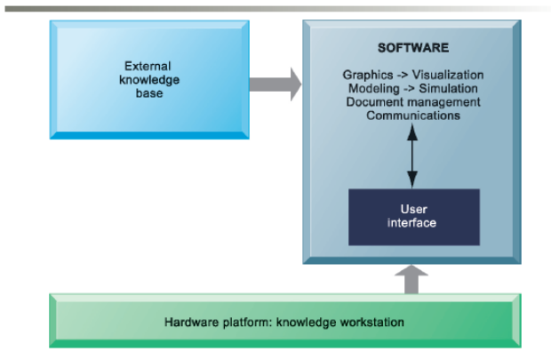

Figure 11.9: Requirements of Knowledge Work Systems

Examples of Knowledge Work Systems

Pick up any business or technology magazine or surf news channels and you’ll find numerous examples of how companies are using knowledge work systems to re-create their core processes, create new products or services, or improve old ones.

Computer-aided design (CAD) applications are used by design engineers to build new products or improve old ones. It used to take 3 to 4 years and millions of dollars to design a new car. With improved CAD systems, automobile manufacturers have reduced the time to 18 to 24 months and cut the cost by millions of dollars.

CAD systems supply data to 3D printing technologies that use machines to produce prototypes and small items on a computer. As manufacturers go through the design process, traditionally they have produced mock-ups of the real thing, using valuable time and resources to construct items they most likely will discard. With 3D printing, they can instead create the parts on a computer system, saving time and money.

Virtual reality systems have sophisticated imagery that makes you feel like you’re “right there!” You may have seen this system on TV shows or in the movies. You’re usually required to wear special equipment that feeds your reactions back to the computer so that it can plan its responses to your input. The U.S. Air Force uses virtual reality systems to help train pilots.

Interactive Session: Technology: The reality of Virtual Reality (see page 446 of the text) describes how some companies are effectively using virtual reality as part of their customer outreach or employee engagement. Other companies, however, do not find value in using virtual reality.

Augmented reality allows you to keep one foot in the real world and put one foot in an enhanced computer-generated imagery world. If you’ve ever watched a professional football game you’ve experienced augmented reality. You know, that yellow line across the field that shows you where the team has to get to for a first down. With every set of downs, the augmented reality line moves to a different location. It’s so real some people are surprised that it appears only on televised broadcasts of football games. Marketers are especially enamored with the idea of interacting with customers in new and different ways. The technology has a bright future as people become more used to the idea that they can experience a myriad of services in new, more fun, and better ways.

Bottom Line: Information and knowledge are key business assets that must be nurtured, protected, grown, and managed for the benefit of the entire organization. Knowledge work systems create and manage knowledge using computer-aided design systems, virtual reality systems, augmented reality, and VRML.

11.5 How will MIS help my career?

The chapter’s elements and information can help in securing a good job as an entry-level sales assistant. This position will work closely with the sales team on planning and staging events, database management, administrative tasks, and account research. These types of jobs are becoming more popular as information technology becomes more important in the workplace.

Discussion Questions

- Discuss the difference between tacit knowledge and explicit knowledge and give some examples of each.

- Discuss management and organization activities necessary to enable information system activities in a knowledge management system. Refer to Figure 11.1 in the text.

- Pick three types of artificial intelligence and describe how they can or already do affect your life and your world.

- How is an expert system different from a neural network?

- Discuss some potential business uses for augmented reality technology.

Answers to Discussion Questions

- Tacit knowledge is undocumented experience and expertise employees keep in their heads. Explicit knowledge is documented usually through reports, e-mails, voice mail, graphics, and video files.

- There are four information system activities in a knowledge management system: acquire, store, disseminate, and apply. Each of them has multiple management and organization activities that must take place to ensure as much knowledge as possible is included in the knowledge business value chain. Figure 11.2 aligns the two sets of activities.

- Student answers will vary but this might be a very fun exercise for them to imagine a new world they will live in.

- Expert systems require people to input all decision-making rules into the rule base. A knowledge engineer pulls information from various sources and fits it into the expert system. A neural network builds upon a base of information and continually learns by itself. Very little human intervention is required for the neural network’s knowledge base to grow.

- Augmented reality combines the real world with computer-generated graphics or other effects that enhance users’ experiences. Some potential uses include:
  - Landscape architects could enhance a photo of your front yard with potential changes.
  - Geologists could use an aerial photo to demonstrate potential flood plains and the effects a flood would have on the area.
  - City planners could project how changing a street’s traffic flow pattern would look before they began construction.
  - Automobile manufacturers could use the technology to show potential customers what a car would like look with various changes in upholstery, colors, or more dashboard features.

